Allen Telescope Array

Interface Document

28.08.2020 Version:1.1

## Location

|  |  |
| --- | --- |
| **Name** | Hat Creek Radio Observatory |
| **Address** | 42231 Bidwell RD, Hat Creek, CA 96040 |
| **Altitude** | 1008 m |
| **Latitude** | 40° 49' 03" N |
| **Longitude** | 121° 28' 24" W |

## Antennas

|  |  |
| --- | --- |
| **Architecture** | 42 dishes – 6.1 m offset Gregorian |
| **Array maximum baseline** | 300 m |
| **Elevation range** | 16 to 87 deg |
| **Max elevation speed** | 1 deg/sec |
| **Azimuth range** | -90 to 450 deg |
| **Max azimuth speed** | 3 deg/sec |
| **Operating frequency** | 1 – 11.2 GHz |
| **Feed design** | Log-periodic |
| **Polarization** | Dual linear |
| **Feed operating temperature** | 80 Kelvin |
| **System temperature ()** | 45 Kelvin @ 2 GHz; 60 Kelvin @ 8 GHz |
| **HPBW** | 3.5° @ 1 GHz; 0.58° @ 6 GHz; 20.9′ @ 10 GHz; |

## Time standard

|  |  |
| --- | --- |
| **Time sync** | GPS (CNS Clock II) |
| **Station clock** | Rubidium |
| **Available reference signals** | 10MHz; 1PPS |
| **Local NTP server** | ntp1-1.hcro.org; ntp2-1.hcro.org; ntp2-2.hcro.org |

## Radio Frequency (RF)

|  |  |
| --- | --- |
| **Cryogenic low noise amplifier** | LNF-ABLNC1_15A; 35dB gain; 1 – 15 GHz |
| **Post amplifier module (PAM)** | 60dB gain; 0 - 63 dB variable attenuator; 0.5 dB step |
| **PAM 1 dB gain compression** | +8 dBm |
| **Analog fiberoptic link converter** | Photonic Systems; PSI 1601 |
| **Fiber link noise figure** | ≤ 45 dB |
| **Fiberoptic 1 dB gain compression** | +11 dBm |
| **Fiberoptic connectors** | FC/APC |
| **Optical wavelength** | 1550 nm |

## intermediate FREQUENCY (IF)

|  |  |
| --- | --- |
| **Number of independent IF bands** | 4 |
| **IF bandwidth** | 700 MHz |
| **Number of tunable LO** | 4 |
| **Number of fixed LO** | 1 |
| **Frequency range of tunable LO** | 16 – 26.7 GHz |
| **Frequency of fixed LO** | 15.95 GHz |
| **AAF center frequency** | 450 MHz |
| **IF output power range** | -10 dBm to -30 dBm |
| **IF output connector** | SMA |

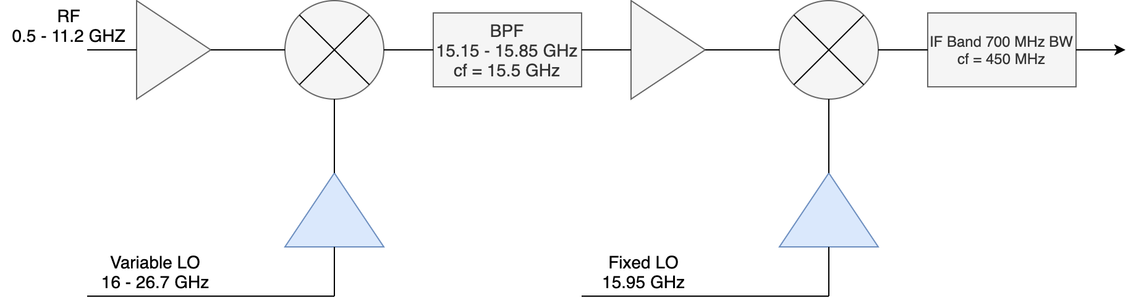

## Control interface

|  |  |
| --- | --- |
| **Telescope control software** | Python 3.5 based library; ATATools.ata_control |
| **GitHub location** | <https://github.com/SETIatHCRO/ATA-Utils> |
| **Software version** | 1.0.3 |
| **Requirements** | 'ephem'; 'astropy'; 'numpy'; 'tftpy'; 'pyuvdata' |

## Network

|  |  |
| --- | --- |
| **Internet connection** | 100 Mbps full duplex |
| **Site access** | VPN; SSH |
| **Available public IPs** | 64 |
| **VPN address** | https://hcro.seti.org |

